**Q4-Tapping Rain Water**

Given n non-negative integers representing an elevation map where the width of each bar is 1, compute how much water it can trap after raining.

Example 1:

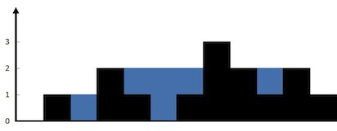

Input: height = [0,1,0,2,1,0,1,3,2,1,2,1]

Output: 6

Explanation: The above elevation map (black section) is represented by array [0,1,0,2,1,0,1,3,2,1,2,1]. In this case, 6 units of rain water (blue section) are being trapped.

Example 2:

Input: height = [4,2,0,3,2,5]

Output: 9

Constraints:

n == height.length

1 <= n <= 2 * 104

0 <= height[i] <= 105